Constraining SOPC Builder Designs with TimeQuest

Introduction
The dramatic increase in FPGA design complexity and I/O implementation has driven Altera to create the new TimeQuest Timing Analyzer. The TimeQuest timing analyzer simplifies the process of both timing analysis and applying design constraints, leading to faster analysis and potential gains in performance. The TimeQuest timing analyzer offers a complete GUI design environment as well as ASIC-tool like features that include native support for Synopsys Design Constraints (SDC) format and full scripting capabilities. The TimeQuest timing analyzer is the default timing analyzer for the Stratix® III and Cyclone® III families and will remain the default for future generations of devices. Altera will continue to include the classic timing analyzer as part of the Quartus® II software tools portfolio for customers designing Cyclone III without high performance external memory or LVDS support and also for legacy designs on previous generations of devices.

The timing analysis tool in earlier versions of Quartus II software is now referred to as the classic timing analyzer (TAN). The design philosophy that many engineers used with the classic TAN was to check the timing results after compilation in Quartus II software to achieve timing sign off. This is especially true for SOPC Builder based designs where much of the external interface timing is easy to meet. Although Altera has recommended the practice of constraining designs before compilation, this is now further encouraged by the use of TimeQuest and the fact that any unconstrained paths are reported by default during the compilation process.

This document discusses how to constrain designs based upon SOPC Builder. This document does not discuss use of TimeQuest for analysis. This is discussed in other Altera® documentation.

Further reading on the TimeQuest timing Analyzer can be found on the website:
- TimeQuest Timing Analyzer (PDF) chapter in volume 3 of the Quartus II Handbook
- Switching to the TimeQuest Timing Analyzer (PDF) chapter in volume 3 of the Quartus II Handbook

Using Synopsis Design Constraints (SDC) Scripts
There are several ways to enter constraints for TimeQuest. Some of these are listed below:
- Enter commands directly on the TimeQuest command line
- Write commands in a text file that are executed as a script
- Use GUI tools to add commands either to the command line or to a script

This document discusses the method of implementing commands as part of a script. All of the commands discussed can be entered into a text file using the TimeQuest SDC file editor or your favorite text editor. The TimeQuest SDC editor has the advantage of providing colored highlighting for keywords and help functions. In order to check the syntax of a command, it can be entered directly onto the command line and then copied into an SDC script.

The following screenshot shows the TimeQuest analyzer which can be launched from Quartus II software by the menu option Tools -> TimeQuest Timing Analyzer.

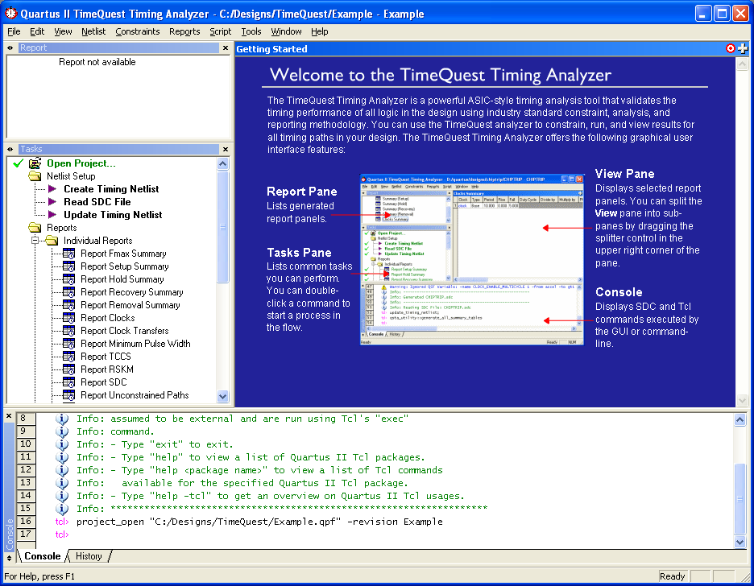

TimeQuest requires a timing netlist in order to perform any analysis or add a constraint. By default, this is a post-fit netlist which requires a compiled design. This is something that is best avoided when creating constraints as the design should be recompiled after adding the constraints to give the fitter more information about the design requirements. Once analysis and synthesis has been completed in Quartus II software, a post-map netlist can be created for TimeQuest. This is done by selecting Netlist -> Create Timing Netlist from the TimeQuest menu. This displays the dialog box shown below. Select post-map as shown and click OK.

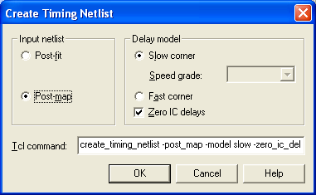
To create a new SDC file, select choose File -> New SDC File from the menu. Add constraints based upon the information provided in the following sections in order to constraint the design. Once the constraints have been entered, save the SDC file and select Constraints -> Read SDC file from the TimeQuest menu. Now browse to the SDC file and click OK. From this point, any of the reports in the report pane can be run. It is advisable to run the Report Unconstrained Paths report in order to check that the design is fully constrained. If not all paths are constrained, then run Reset Design from the report pane, add more constraints to the SDC file and repeat.

Finally, ensure that the Quartus II software is set up to use the TimeQuest timing analyzer and select the correct SDC file. Choose Timing Analysis Settings from the Assignments -> Settings menu and select Use TimeQuest Timing Analyzer During Compilation. Then select TimeQuest Timing Analyzer from the same dialog box and add the SDC file. The Quartus II software will now use TimeQuest with the SDC file for compilation and timing analysis.

Design Elements
The constraints discussed in this document are associated with specifying clocks, I/O timing and false paths. For each constraint, it is necessary to provide some kind of reference to one or more design elements. The terms used by TimeQuest are shown in the table below.

Term | Definition
Nodes | Most basic timing netlist unit. Used to represent ports, pins, registers, and keepers.
Keepers | Ports or registers
Cells | Look-up table (LUT), registers, DSP blocks, TriMatrix™ memory, IOE, etc.
Pins | Inputs or outputs of cells.
Nets | Connections between pins.
Ports | Top-level module inputs or outputs; for example, device pins.
Clocks | Abstract objects outside of the design.

There are various commands that can be used to find these design elements such as get_ports which returns a collection of ports based upon a space separated list supplied that may contain wild cards. Consider an 8 bit register with the following ports:
clk
reset
data[7..0]
q[7..0]

get_ports {clk} returns the clk port
get_ports {clk reset} returns the clk and reset ports
get_ports {data[*]} returns the data bus
get_ports {q[0] q[1] q[2] q[3]} returns the lower nibble of the q bus
get_ports {*} returns all of the ports

Commands such as get_ports are used throughout the remainder of this document in order to apply constraints to design elements.

External Clock Inputs
Each clock input to the SOPC system needs to be defined using the create clock command. This specifies the period of the clock and assigns it to the relevant FPGA input. For example, the following command creates a 50 MHz clock called master_clk and assigns it to the input clk_in:

create_clock –period 20 –name master_clk [get_ports {clk_in}]

This command assumes a 50% duty cycle. If this is not the case, the –waveform option can be used. The –waveform option uses a 2 item list to specify the rising edge followed by the falling edge. In order to specify a 60% duty cycle, the following command would be used:

create_clock –period 20 –waveform {0 12} –name master_clk \
[get_ports {clk_in}]

If there are more than one external clock inputs to the system and they are related, then multiple create clock commands should be used with the –waveform option to specify the relationship.

Consider the two related clocks shown below:
clk_a
clk_b
0 3 5 10 13 23 ns
These can be assigned with the following commands:

create_clock –period 10 –waveform {0 5} [get_ports {clk_a}]
create_clock –period 10 –waveform {3 13} [get_ports {clk_b}]

Note that in this example the –name option is omitted. In this case, the clocks will be given the name of the first item in the target collection. In this case, the collection specified by get_ports is only expected to return a single port and so the clock names will be clk_a and clk_b.

If more than one clock inputs are present but are unrelated, then the paths between them can be cut assuming that the circuitry implemented handles asynchronous clock domain transfers. In order to specify that TimeQuest should not analyze paths between the two clock domains defined above, use the following commands:

set_false_path –from [get_clocks {clk_a}] –to [get_clocks {clk_b}]
set_false_path –from [get_clocks {clk_b}] –to [get_clocks {clk_a}]

Note that there are two assignments made, one for each direction between the two clock domains.
NB: If there are unrelated asynchronous clocks in the system, it is the designer’s responsibility to ensure that the circuit handles any clock domain crossing appropriately.

Both the clock domain crossing adapter and the Avalon-MM Clock Crossing Bridge components within SOPC Builder handle clock transfers appropriately. The clock domain crossing adapter is added automatically when a master and slave connection is made between two clock domains.

PLL
There are two ways of defining clocks generated by PLLs in the system. One is to use the create_generated_clock command for each clock output; the other is to use the derive_pll_clocks command which generates clocks for all PLL outputs in the Quartus II design. Here we will discuss derive_pll_clocks as it has the advantage of automatically defining clock rates and phase shifts. To generate clocks for all outputs within the system, use the following command:

derive_pll_clocks

Consider the SOPC system shown below. This comprises a single clock input and one PLL using a single output.

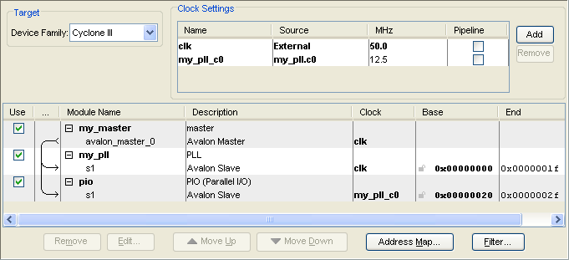

After running the following commands in TimeQuest, two clocks are generated:

create_clock -name master_clk -period 20 [get_ports {clk}]
derive_pll_clocks

The clocks generated can be displayed by running the Report Clocks report within the task pane in TimeQuest. This displays the following:

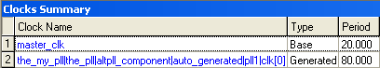

Clock 1 was generated by the create_clock command, and clock 2 was generated by derive_pll_clocks. For the generated clock, it is important to take note of the start and end of the name as follows:

the_my_pll
This is the instance name at the first level of hierarchy within the Quartus II design. In this case the SOPC system is the top level and so the hierarchical path starts there. the_my_pll is an instance name given to the specific instance of the PLL in this system and is always the_<module_name>

clk[0]
This is the output of the PLL. In this case only the c0 output of the PLL is used. If the c1 output was also used, there would be another generated clock called the_my_pll|the_pll|altpll_component|auto_generated|pll1|clk[1].

If the SOPC system was not at the top level but one level down, the generated clock would be called <sopc_instance>|the_my_pll|the_pll|altpll_component|auto_generated|pll1|clk[1]
where <sopc_instance> is the name given to the instance of the SOPC system by the higher level block.

Although the derive_pll_clocks command is useful, the generated names are usually long and not indicative of their use. The standard TCL command set can be used to assign a more suitable name as shown:

set pio_clk \
the_my_pll|the_pll|altpll_component|auto_generated|pll1|clk[0]

This name can then be referenced in other commands such as those shown below which set false paths between the two clock domains in this system:

set_false_path -to $pio_clk -from master_clk
set_false_path -to master_clk -from $pio_clk

Note that this is a valid thing to do in this system as the clock domain crossing adapter added by SOPC builder is designed to cross asynchronous clock domains safely.

Reset Input
To maintain a good synchronous design, SOPC Builder implements reset synchronization circuitry for each clock domain in the system. The reset synchronization circuit is shown below:
1
clk
reset_n
reset_out_n
This ensures that all of the registers within the clock domain fed by reset_out_n see the same release of the reset condition. Without this circuit, different registers may see a different first clock edge after reset release if the reset is released close to an active clock edge. As this circuit handles asynchronous inputs correctly, there is no need to consider the timing between the reset input and any register driven directly by it. Therefore, a false path should be specified to tell TimeQuest that this path is not to be analyzed and can be excluded from the unconstrained paths report. The reset_out_n port of this circuit drives asynchronous reset and clears of registers within the clock domain and is analyzed as recovery and removal. The recovery and removal reports within TimeQuest can be run to report this timing.

The assignment required takes the following format:

set_false_path –from [get_ports {<reset_signal>}]

where <reset_signal> is the pin name of the reset pin in the design.

Slow Asynchronous I/O
We typically see the use of slow asynchronous I/O in an SOPC Builder based system such as PIO and UART peripherals. As these I/O are asynchronous to the clock that is used to capture or output data, there is no need to analyze the timing and so false paths should be set.

For outputs, a false path should be set between the launch clock and the output. For inputs, a false path should be set between the input and the latch clock. For bi-directional signals, false paths should be set from launch clock to pin and also from pin to latch clock. Launch and latch clocks are typically the clocks associated with the SOPC Module that includes the I/O.

For the system described in the PLL section of this document, the following command can be used to set false paths for the PLL outputs:

set_false_path -from $pio_clk -to [get_ports {*_pio[*]}]

As this design contains an 4 bit PIO, the filter *_pio[*] captures the following I/O pins.
out_port_from_the_pio[0]
out_port_from_the_pio[1]
out_port_from_the_pio[2]
out_port_from_the_pio[3]
NB: Care should be taken when using wildcard filters to ensure that unwarranted nodes or I/O are not captured by mistake.

Single Data Rate SDRAM and SSRAM
Single data SDRAM interfaces used within SOPC Builder typically utilize the following type of circuit. Here, a PLL is used to phase shift the clock to the external memory in order to meet I/O timing requirements.

FPGA
SDRAM Controller
SDRAM
Ext clk
SDRAM clk
Addr & Ctrl
DQ
PLL

There are two steps required in order to constrain this interface. First a clock is created that will be seen by the external SDRAM; then the I/O timing is set relative to that clock.

Concepts that have already been discussed allow the creation of a PLL output clock and the setting of a TCL variable for that clock as follows:

create_clock -period 20.000 -name ext_clk [get_ports {clk}]
derive_pll_clocks
set sdram_clk my_pll_inst|altpll_component|auto_generated|pll1|clk[0]

The create_generated_clock command can then be used to define a clock as seen by the external memory. This generated clock will automatically add delays associated with routing to the clock output pin and the delay of the pin itself. There will also be some board delay due to the PCB track between the FPGA and SDRAM that will have be included by the user by use of the -offset option.

The following command specifies a clock called sdram_clk_pin associated with the clock output pin sdram_clk. A 0.5 ns offset is included to allow for PCB routing delay.

create_generated_clock -name sdram_clk_pin -source $sdram_clk \
-offset 0.5 [get_ports {sdram_clk}]

There may be some uncertainty associated with the PCB delay that is not included here. The uncertainty can be included in the I/O constraints that are specific to input or output and minimum or maximum delays.

The I/O constraints must be defined in relation to the data sheet for the external memory. The following is an extract from a data sheet for an SDRAM device with the worst case input and output timing highlighted for a CAS latency of 3.

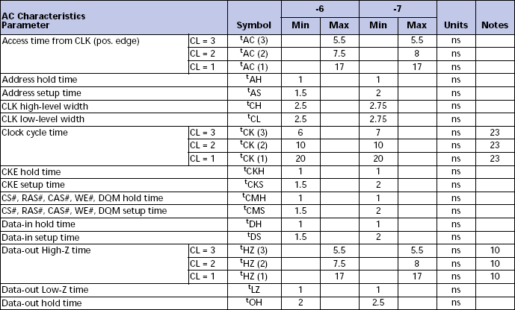

The following I/O timing is noted (input/output from the perspective of the memory)
Max clock to out: 5.5 ns t_{AC(3)}
Min clock to out: 2.5 ns t_{OH}
Min setup: 2.0 ns t_{CMS}
Min hold: 1.0 ns t_{CMH}

NB: This is the worst-case timing for this particular SDRAM. Other devices may have worst-case timing associated with different timing parameters.

The mapping of external memory timing to FPGA I/O delays is noted in the table below. This also shows whether the minimum or maximum PCB routing delay should be used, which must be added to the FPGA delay constraints.

Memory Timing | FPGA timing | PCB routing
Max clock to out | Max input delay | Max
Min clock to out | Min input delay | Min
Min setup | Max output delay | Max
Min hold | Min output delay (-ve)* | Min
*The constraint for minimum output delay is actually 0 – Min hold.

The set_input_delay and set_output_delay commands can be used to set the I/O constraints. In the examples below, a common PCB routing delay of 0.5 ns ± 0.1 ns is used resulting in 0.4 ns or 0.6 ns being added to the timing information from the SRAM data sheet.

set_input_delay -clock sdram_clk_pin -max [expr 5.5 + 0.6] <ports>
set_input_delay -clock sdram_clk_pin -min [expr 2.5 + 0.4] <ports>
set_output_delay -clock sdram_clk_pin -max [expr 2.0 + 0.6] <ports>
set_output_delay -clock sdram_clk_pin -min [expr 1 – (1.0 + 0.4)] \
<ports>
In each of these commands, <ports> should be a list of I/O ports for the relevant constraints as shown in the example below:
set_output_delay -clock sdram_clk_pin -max [expr 2.0 + 1.2] \
[get_ports {cas_n ras_n cs_n we_n addr[*]}]

Alternatively, multiple set_input_delay and set_output_delay commands can be used to set different delays for different I/O.

Tri-state Bridge and Asynchronous Devices
This section discusses the timing constraints associated with the Avalon tri-state bridge and asynchronous external devices such as the CFI Flash and user tri-state components. These components are typically slow compared with the FPGA, and SOPC Builder generates logic within the interface to control timing across multiple clock cycles. This is defined by the user by entering data for set up, wait and hold times.

Before discussing the assignments required to constrain this interface, it is best to review the process for determining the set up, wait and hold time. Timing information for both the external device and FPGA can be obtained from their respective datasheets.

Consider the following example timing for an external memory device:

Memory Read Requirements

address
oe_n
data
ce_n
R2
R1
R3
R4
R1: worst case signal to output valid 95 ns
R2: oe_n to output valid 25 ns
R3: largest signal to data high Z time 24 ns
R4: smallest signal to data high Z time 0 ns

Memory Write Requirements

W3
address
we_n
data
ce_n
W4
W2
W1

W1: worst case set up to we_n low 0 ns
W2: minimum we_n low pulse width 50 ns
W3: worst case set up to we_n high 50 ns
W4: worst case hold from we_n high 0 ns

FPGA Timing Example

Tco: max output delay from FPGA 4 ns
Tsu: max input delay to FPGA 4 ns
Th: max hold time for FPGA -2.5 ns
Tcyc: clock period used for the interface* 20 ns

Tpcb: worst case PCB delay* 0.5 ns

*This is an assumed value for the purposes of example calculations later in this section.

Wait Time
Calculate this parameter first as it is used for other calculations. Both read and write transactions should be examined to determine which has the critical timing. For reads, the concern is with the delay of the oe_n signal from the FPGA to the external device, plus the access time, plus the set up time for the data input to the FPGA plus the PCB delays in both directions. This is known as the round trip delay and can be calculated as follows:

Twait = Tco + Tpcb + R2 + Tpcb + Tsu = 34 ns

For writes, the minimum wait time is simply equal to the minimum we_n low time:

Twait = W2 = 50 ns

Therefore the wait time will be 50 ns.

Setup Time
This is the time required for signals to be stable prior to the oe_n or we_n signals going low. In this example, there is no explicit set up time between oe_n and other signals. Therefore, a calculation is used to determine the set up time based upon the worst case access time as follows:

Tsetup = Tco + Tpcb + R1 – Twait = 49.5 ns

For writes, the set up time required is determined by either the set up time before we_n goes low or the set up time for we_n going high less the wait time. Therefore, including PCB and FPGA delays the set up time for writes is the largest or the following calculations

Tsetup = Tco + Tpcb + W1 = 4.5 ns
Tsetup = Tco + Tpcb + W3 – W2 = 4.5 ns

Therefore the wait time is 49.5 ns

Hold Time
Hold time is only applied to writes and is determined by the worst case hold time plus FPGA and PCB delays.

Thold = Tco + Tpcb + W4 = 4.5 ns

Note that for reads followed by writes, an extra cycle or two is added by the registers associated with the tri-state bridge. One cycle is added to register the outputs, and an extra cycle is added if registered inputs are enabled, which is the default setting.

When this information is entered into SOPC Builder, a synchronous state machine is generated and so the timing is extended to the next clock cycle. Therefore, the timing that will be generated is as shown in the waveforms below based upon an assumed cycle time of 20 ns:

SOPC Read Waveforms
address
read_n
data
clk
3 set up
3 wait
SOPC Write Waveforms
address
write_n
data
clk
3 set up
3 wait
1 hold
Notes:
- The read_n signal is usually mapped to the oe_n signal of the external device
- The write_n signal is usually mapped to the we_n signal of the external device

Setting Constraints
With these types of interfaces, the timing is controlled by a state machine that gets generated based upon the information entered into the component editor. Since datasheet values for the FPGA were used in calculating the timing, the constraints required simply ensure the data sheet timing is met. Adding these constraints ensures that issues associated with data sheet miss-interpretation and fitting problems that affect I/O timing are captured.

TimeQuest uses constraints that are based upon the timing of the external device. The following equations are used to convert from required FPGA timing to input and output delays:

max_output_delay = Tcyc – Tco = 20 – 4 = 16 ns
min_output_delay = 0 ns
max_input_delay = Tcyc – Tsu = 20 – 4 = 16 ns
Min_input_delay = Th = – 2.5 ns

Zero is used for the minimum output delay when is no datasheet value specifying otherwise.

The commands required to set these constraints are as follows:

set_output_delay –clock <clock_name> -max <max_output_delay> <ports>
set_output_delay –clock <clock_name> -min <min_output_delay> <ports>
set_input_delay –clock <clock_name> -max <max_input_delay> <ports>
set_input_delay –clock <clock_name> -min <min_input_delay> <ports>

Important Notes
The constraints and methods described above are somewhat simplistic as they assume minimum delays of 0. Whilst this is sufficient for many devices, it may show timing violations that are due to these assumptions whereas more complex methods that give a more accurate analysis would pass timing analysis.

The calculations, constraints and example values above assume that there is no PLL used for the interface clock. If a PLL is used, then its phase shift in relation to the interface I/O timing needs to be taken into account.

DDR and DDR2 Memories
When using Cyclone III and Stratix III devices, the Altera High-Performance DDR and High-Performance DDR2 MegaCore® functions should be used. These come complete with parameterization wizards that are used to generate TimeQuest constraint scripts. The only requirement from the user is to ensure that the DDR or DDR2 script is used during compilation and timing analysis with TimeQuest. Multiple SDC constraint files can be included in a project by simply adding them to the Assignments -> Settings -> files dialog box.

NB: As these cores make use of the derive_pll_clocks command, warnings will be reported if this is subsequently called by the user constraint file.

Conclusion
The constraints required for SOPC-based designs are covered in this document. Due to the wide variety of designs and virtually infinite number of external interfaces that can be used with SOPC Builder, it is impossible for this document to be foundation in constraining designs and provide an excellent basis for more complex systems.

